gateway的配置过滤器分为两种

①：全局过滤器

全局过滤器 不需要在配置文件配置，所有到服务的请求都会进行拦截，

/\*\*

\* @author 荡漾

\* @title: TokenFilter

\* @projectName gateway

\* @description: TODO token校验全局过滤器

\* @date 2019/6/21 12:41

\*/

@Configuration

@Slf4j

public class TokenFilter implements GlobalFilter, Ordered {

@Override

public int getOrder() {

return -10000;

}

@Override

public Mono<Void> filter(ServerWebExchange exchange, GatewayFilterChain chain) {

return chain.filter(exchange);

}

}

②：指定过滤器

需要继承 AbstractGatewayFilterFactory

优点，可在配置文件中配置，可以为某个服务指定过滤器，

只需把filter对应的名字写入配置文件即可如图：

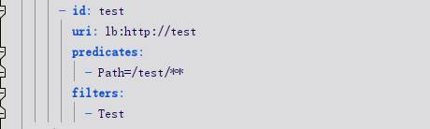

这里值得注意的是， 如果你filter的名称后缀是 GatewayFilterFactory 如 TestGatewayFilterFactory 在配置文件中只需要写Test即可 如果不是那就写全称就可以了

@Component

@Slf4j

public class Test extends AbstractGatewayFilterFactory<Test.NameConfig> {

public Test() {

super(NameConfig.class);

log.info("Loaded GatewayFilterFactory [Authorize]");

}

@Override

public GatewayFilter apply(Test.NameConfig config) {

return (exchange, chain) -> {

System.out.println("= = = = = = 执行了= = = = = = = =");

return chain.filter(exchange);

};

}

public static class NameConfig {

private String name;

public String getName() {

return name;

}

public void setName(String name) {

this.name = name;

}

}

}